Exp. No: 5 Determination and plotting of Electric potential difference between any
two points in free space medium separated by a distance R.
Date:
Aim:
To write program for Electric potential difference between two points in free space medium using
SCILAB.

Software required:
•SCILAB version 6.0.1
PROGRAM;
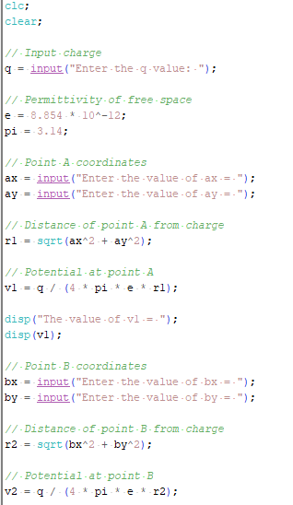
OUTPUT :
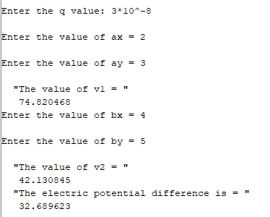
CALCULATIONS :
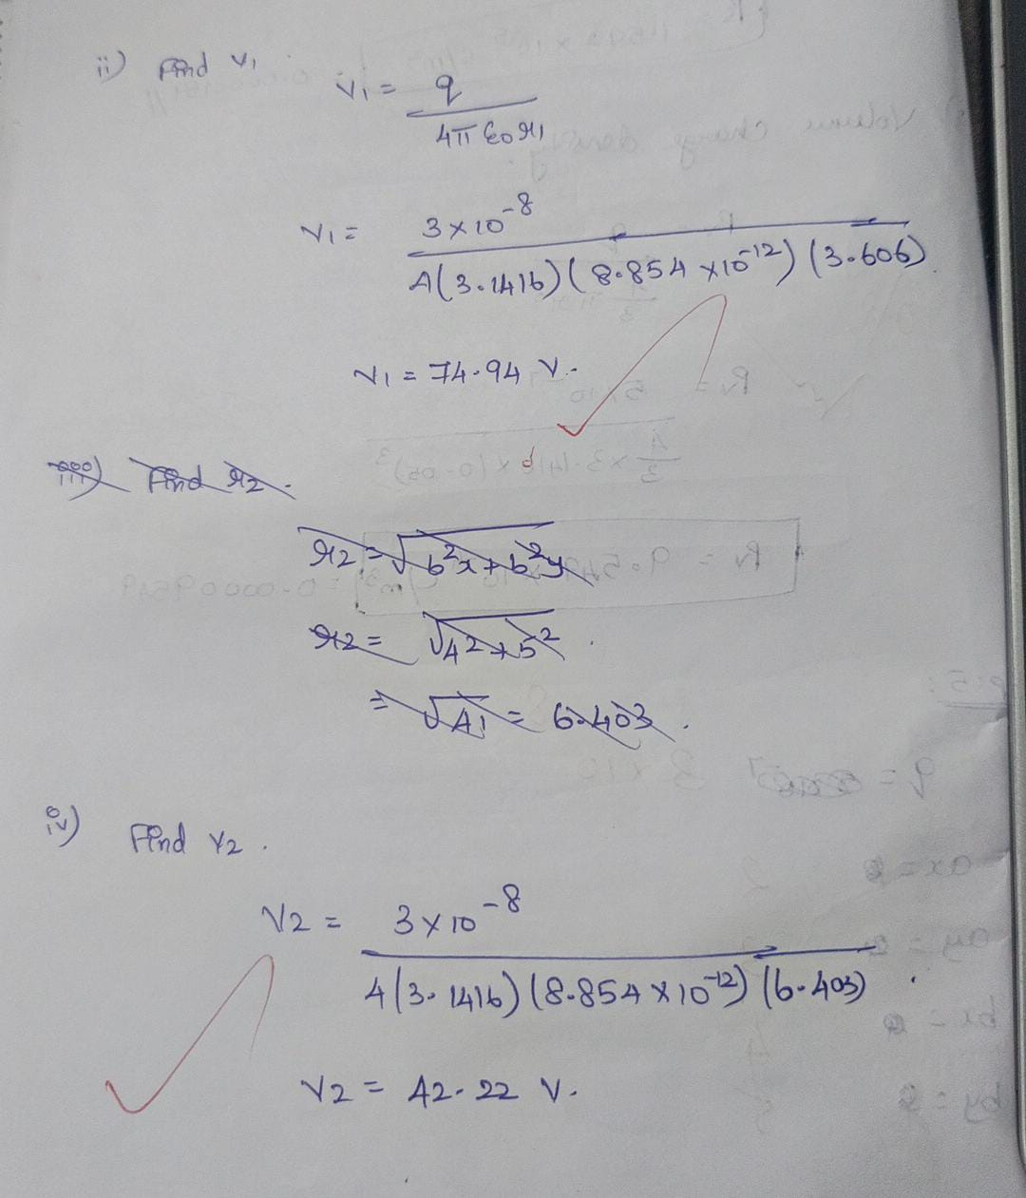

Case 1: A positive charge with fixed r1=1 m r2 varying
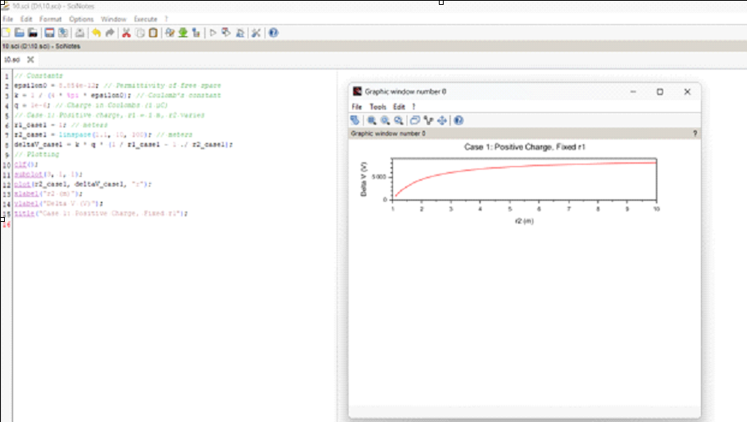
Case 2: A negative charge with r1r_1r1 fixed and r2r_2r2 varying.
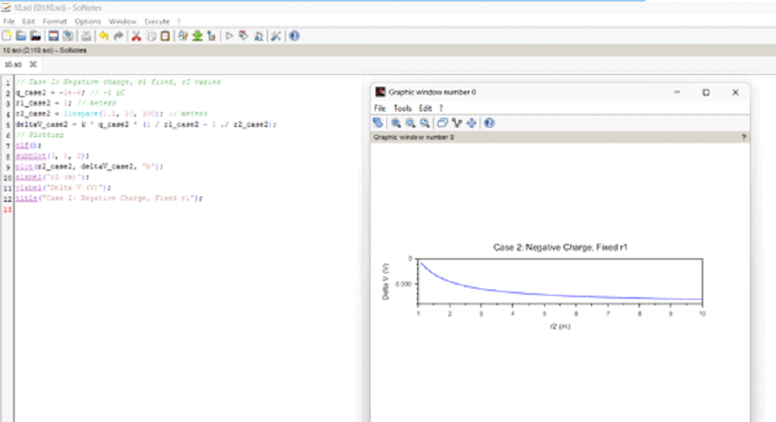
Case 3: Both points r1r_1r1 and r2r_2r2 vary with a positive charge.
